**Name: Mayank Trivedi**

**Module -1: Understanding of Hardware and Its Components**

**Section 1: Multiple Choice**

1.Which of the following is NOT a component of the CPU?

1. ALU

2. RAM

3. CU

4. 1 and 3 both  
 Ans: Ram

Reason:- Ram is not a Component of CPU because it is separate chip on motherboard, not inside a cpu.

2.What is the function of RAM in a computer?

Ans: RAM(Random access memory) is used to temporarily store programs and data while the computer is running. It allows the CPU to access software and data quickly. Once the software is closed or the computer is turned off, the data in RAM is removed.

3. Which of the following is a primary storage device?

1. HDD

2. SSD

3. SD card

4. 1 and 2 both  
 Ans:4. None of them

4. What is the purpose of a GPU?

Ans: A GPU (Graphics Processing Unit) is a chip that design mainly for graphics and parallel processing.It handles complex calculation required for rendering images, videos, and animations.Commonly used gaming, rendering, 3d work, video editing and machine learning.

**Section 2: True or False**  
5. True or False: The motherboard is the main circuit board of a computer where other components are attached.  
 Ans: True  
6. True or False: A UPS (Uninterruptible Power Supply) is a hardware device that provides emergency power to a load when the input power source fails.  
 Ans: True

7. True or False: An expansion card is a circuit board that enhances the functionality of a component.  
 Ans: True

**Section 3: Short Answer**

8.Explain the difference between HDD and SSD.

Ans. HDD (Hard Disk Drive) :

* Uses spinning magnetic disks
* Slower than ssd
* Less durable
* Cheaper than ssd
* Data can be retrieve after failure

SSD(Solid State Drive) :

* Uses flash memory chips
* Faster than hdd
* More Durable
* More expensive than hdd
* Data cannot be retrieve after failure

9.Describe the function of BIOS in a computer system.

Ans: The BIOS(Basic Input/Output System) initializes and tests hardware components during startup and loads the operating system from storage into memory.

10. List and briefly explain three input devices commonly used with computers.

Ans: **(i)**Keyboard: Used to enter text,numbers, and commands into the computer.

**(ii)**Mouse: A pointing device used to move a cursor on the screen, select items, and interact with graphical interfaces.

**(iii)**Scanner: Capture images or documents and converts them into digital form for use in the computer.

**Section 4: Practical Application**

11. Identify and label the following components on a diagram of a motherboard:

● CPU

● RAM slots

● SATA connectors

● PCI-E slot

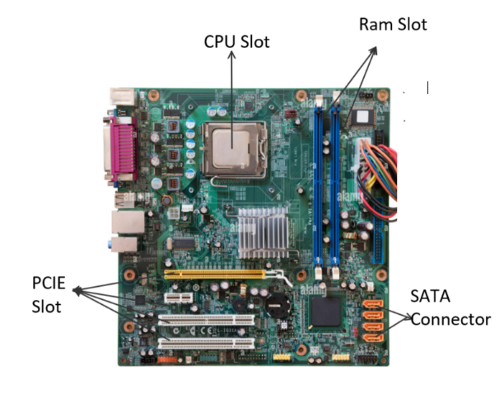

* CPU – A socket with multiple pins.It is a square chip.
* RAM Slots – Vertical Long thin slots,
* SATA Connectors – Small, L-shaped connectors
* PCI-E Slot – Long horizontal slot used to install graphics cards, wifi cards or other expansion cards

2. Demonstrate how to install a RAM module into a computer.

Ans: Step-by-Step Process:

1. Turn off the computer and unplug it.

2. Open the case and remove side panel to see motherboard.

3. Find the RAM slots.

4. Identify which ram is supported written on slot.

5. Insert the RAM stick. Match the notch on the RAM with the ridge in the ram slot.

6. Press down lightly.

7. Close the case and reconnect Power.

8.Turn on the PC

Ram is installed…

**Section 5: Essay**

13. Discuss the importance of proper cooling mechanisms in a computer system. Include examples of cooling methods and their effectiveness.

Ans: Proper cooling mechanisms are crucial in a computer system because moderns CPUs, GPUs, and other components generate too much heat during opeations. If heat is not managed efficiently, it can lead overheating and start throttle their performance.

Importance of Cooling Methods:

1.Maintains Performance:High temperatures can cause CPUs or GPUs to throttle their speed to prevent damage, reducing overall system performance.

2.Prevents Hardware Damage:Excessive heat can damage circuits and reduce the longevity of components.

3.Enhances Stability:Proper cooling ensures that the system operates reliably, even under heavy workloads like gaming, video editing, or data processing.

Examples of Cooling Methods:

1.Air Cooling:

- Most common method using fans and heat sinks to dissipate heat.Fans move air across metal heat sinks attached to components.

-Effectiveness: Adequate for most users, cost effective and easy to maintain

2.Liquid Cooling

- Uses a pump, radiator, and water blocks to carry heat away from components.

Effectiveness:More efficient than air cooling, especially for high-performance gaming PCs

3.Passive Cooling:

- Uses large heat sinks without fans to dissipate heat naturally

- Effectiveness: Silent and mainatainess-free, but limited to low power systems

4.Advanced Cooling:

-Methods like phase-change cooling or thermoelectric cooling are used in extreme scenarious for overclockers

-Effectiveness: Highly efficient but expensive and complex

Conclusion:

Proper cooling is essential for system performance, stability, and longevity.

14. Explain the concept of bus width and its significance in computer architecture.

Ans: The **bus width** refers to the number of bits that can be transmitted simultaneously on the bus.

Like:- CPU, Memory, Storage devices

Important: -

1. Faster Data Transfer

2. Improving Performance

3. Compatibility Bus width determines the amount of data a processor can handle at once

Example: -

A 64-bit bus can transfer 8 bytes at once.